Google OBS and you should see the following:
Begin to download the software by clicking here………
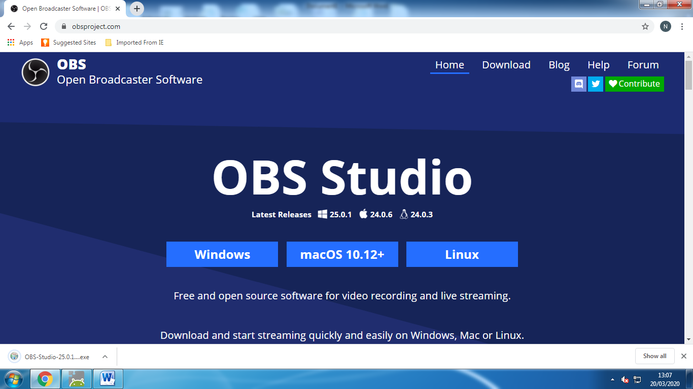

The file download should appear here ………
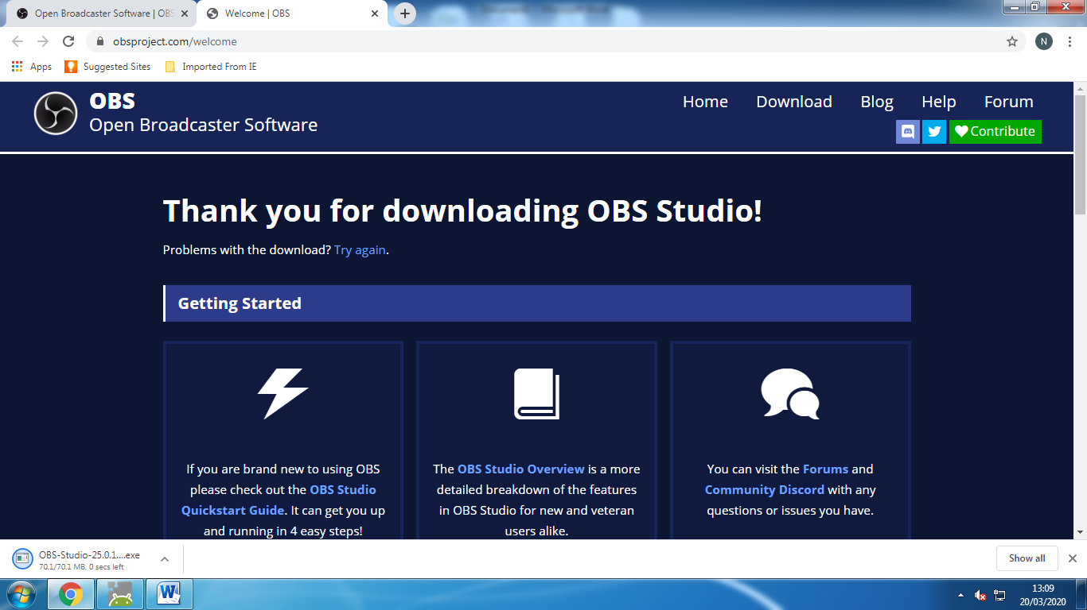

When this is downloaded click on this and then click run on the pop up box
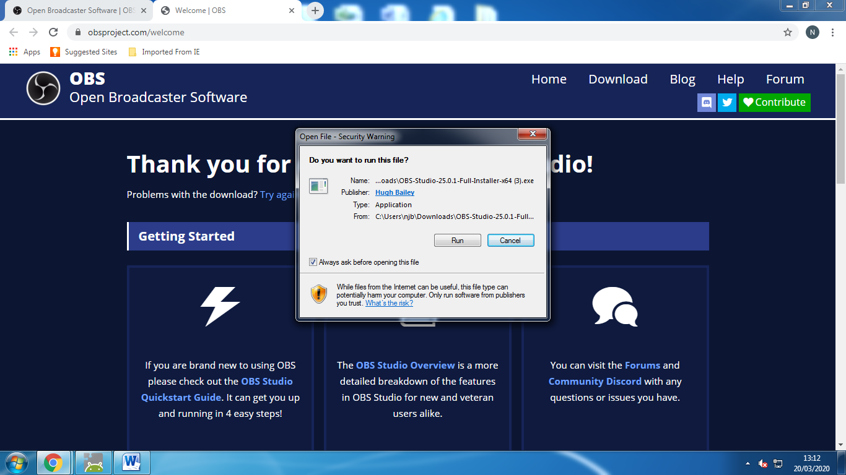

Follow the on-screen instructions:
Next, Next, Install, Finish

Once the software is launched you will see this. Follow the onscreen instructions to set up the software.
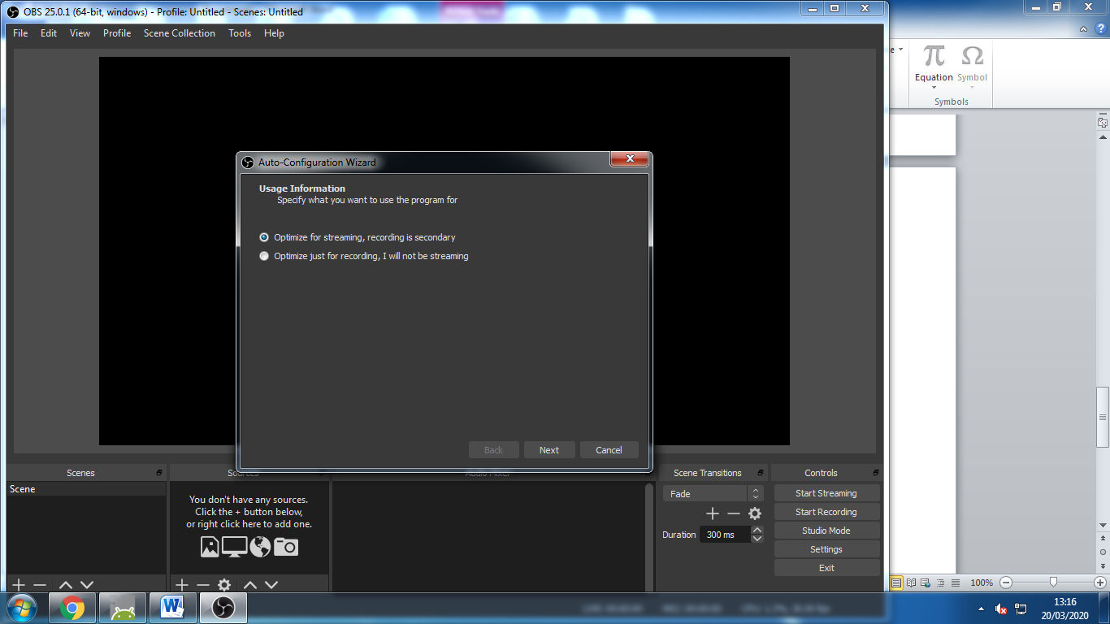

To add both audio and visual capture devices, do the following:
Click the + here ……….
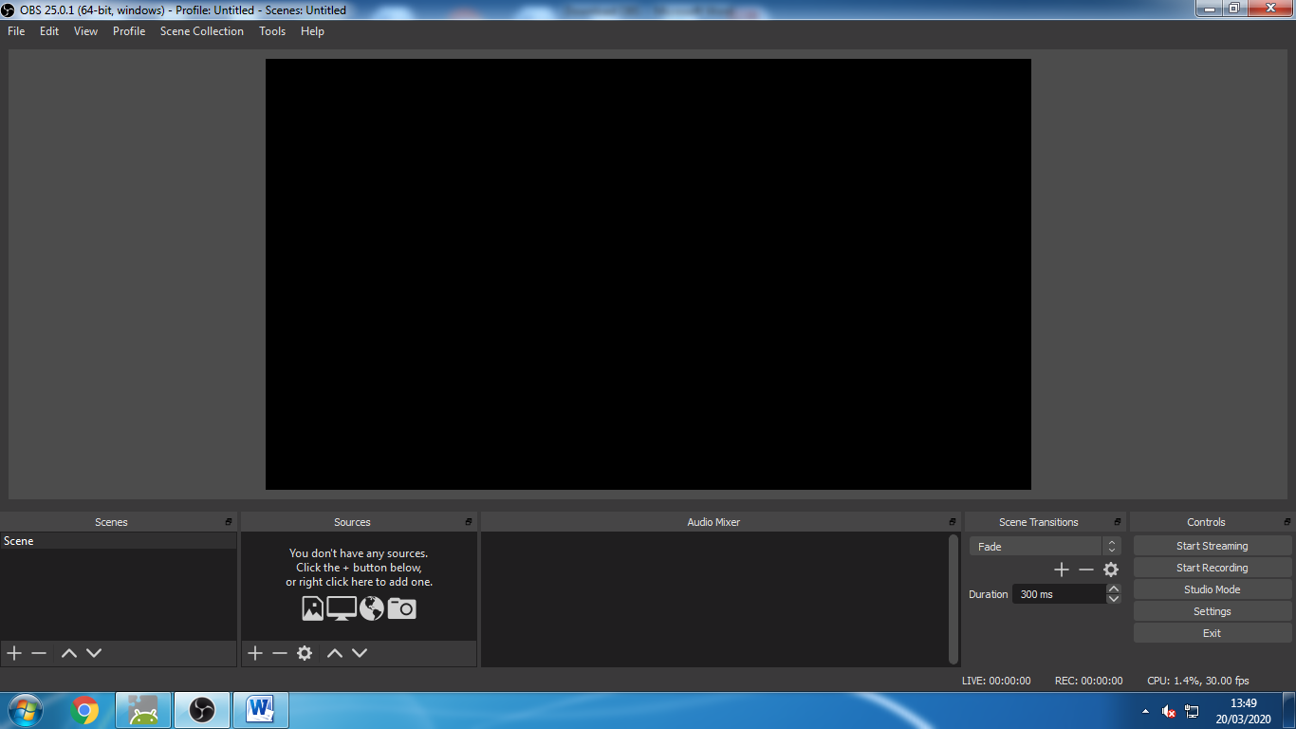

Click display capture
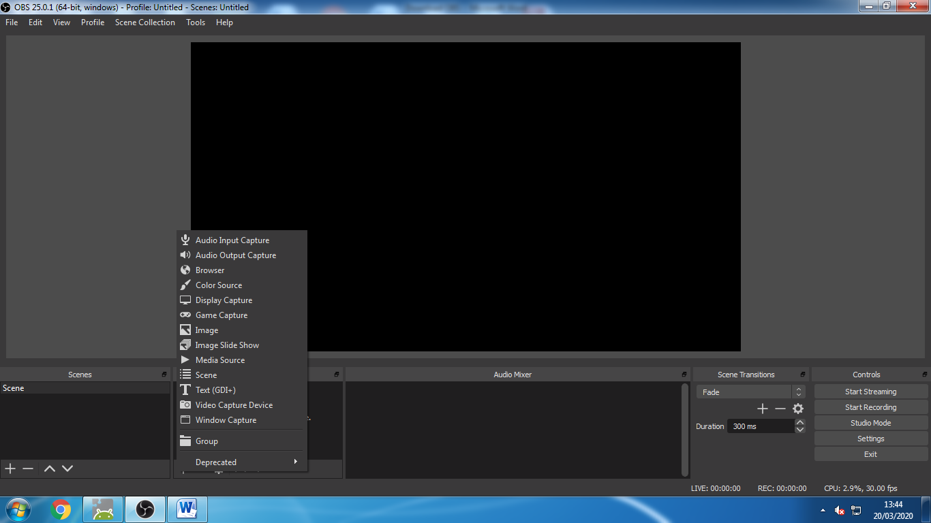

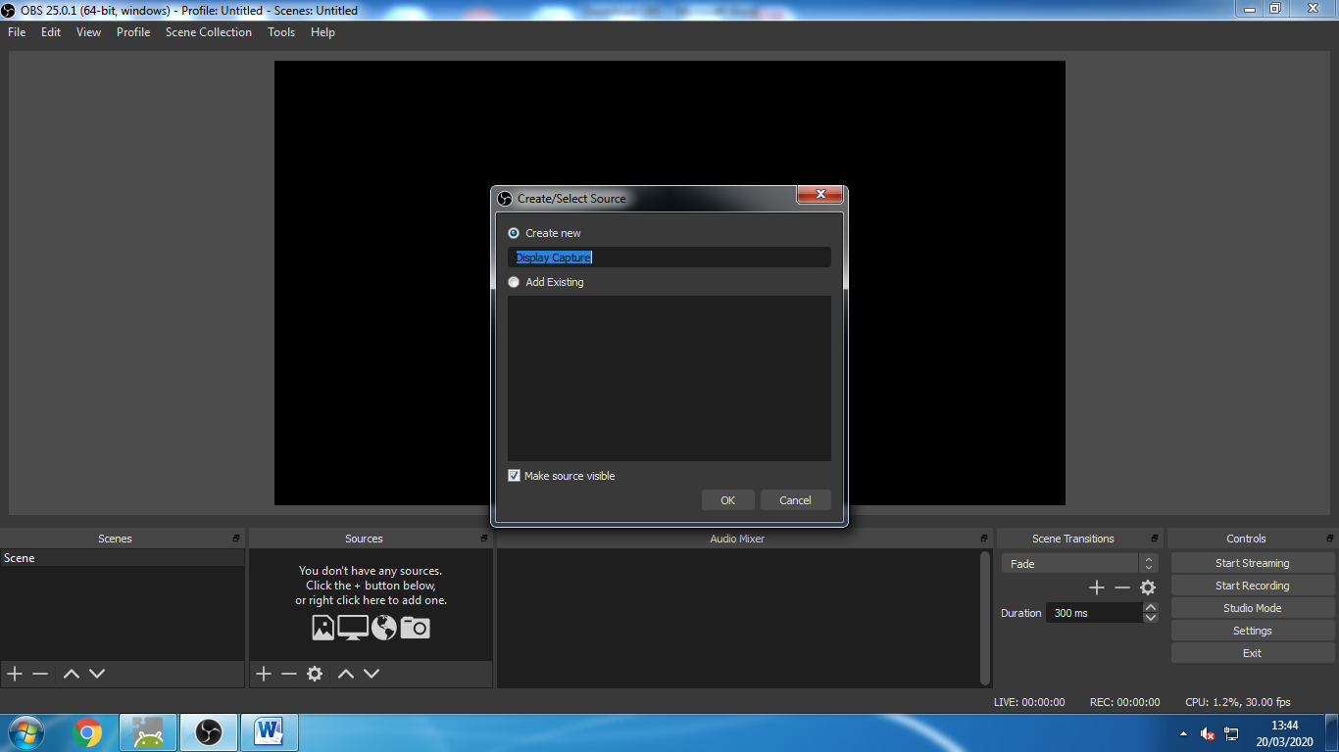

Click OK and you will see the following below (don’t worry that you can see multiple screens)
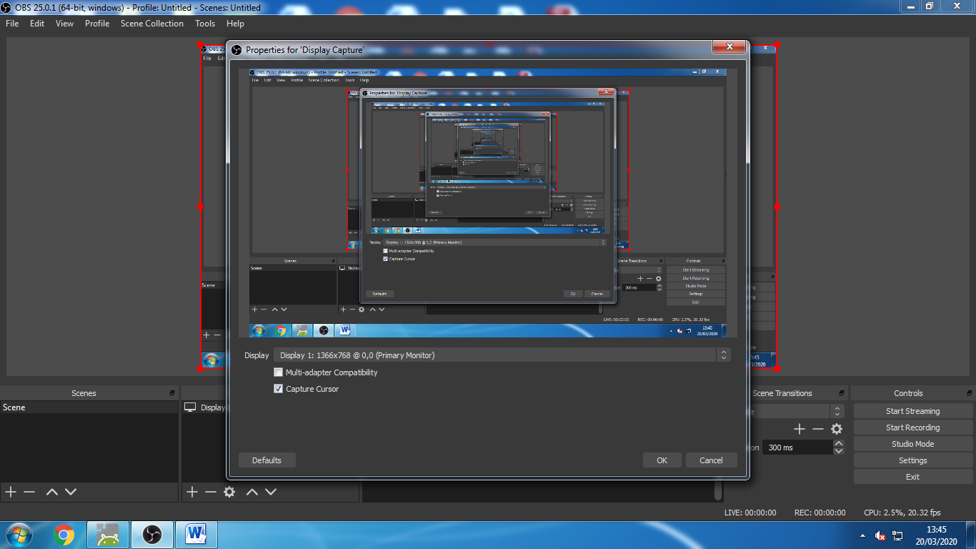
Click audio input capture
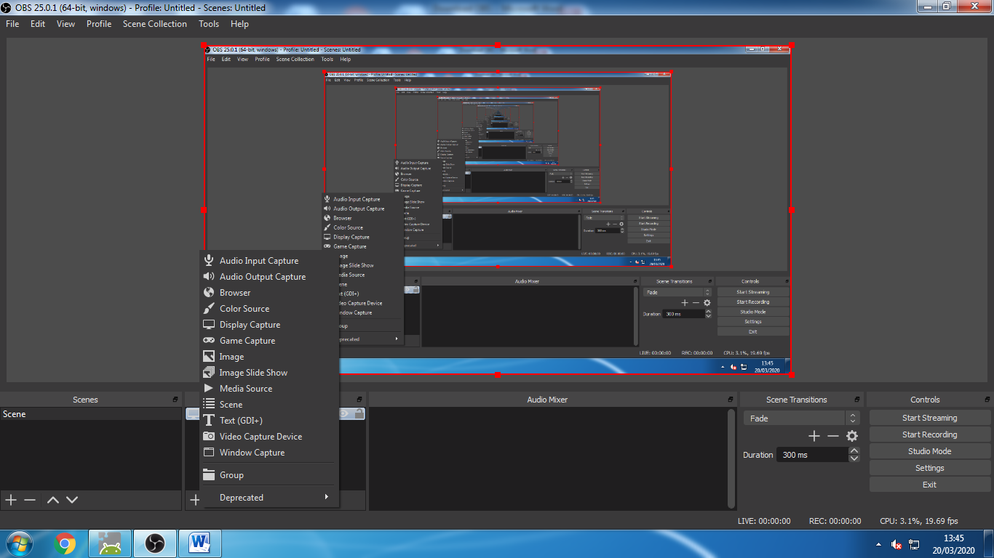

Any audio input should be listed here. This could be:
- Your visualiser
- Inbuilt microphone
- External microphone
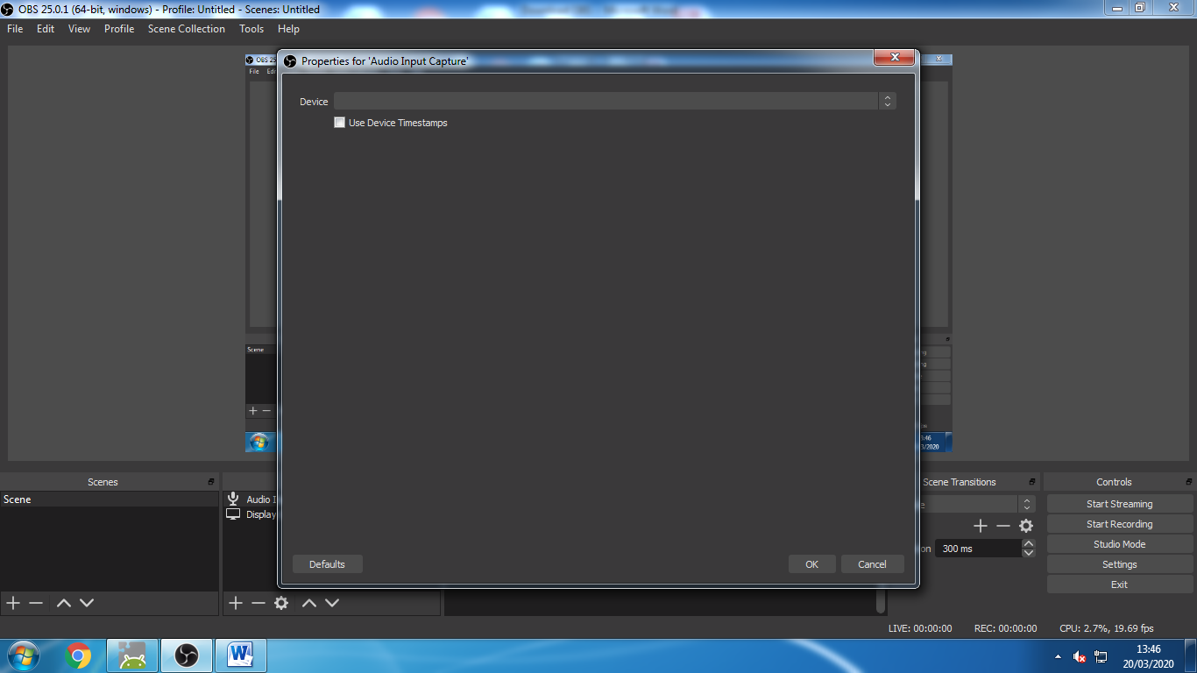
Repeat this process for audio output if you want to play videos as part of your screen capture.
Now watch the tutorial video for further setting s and possible uses.
TIP – Try recording a 10 second video and watching it back before creating your resources
TIP 2 – Videos are too large to upload to SMHW. Save them to OneDrive and share the link via SMHW

